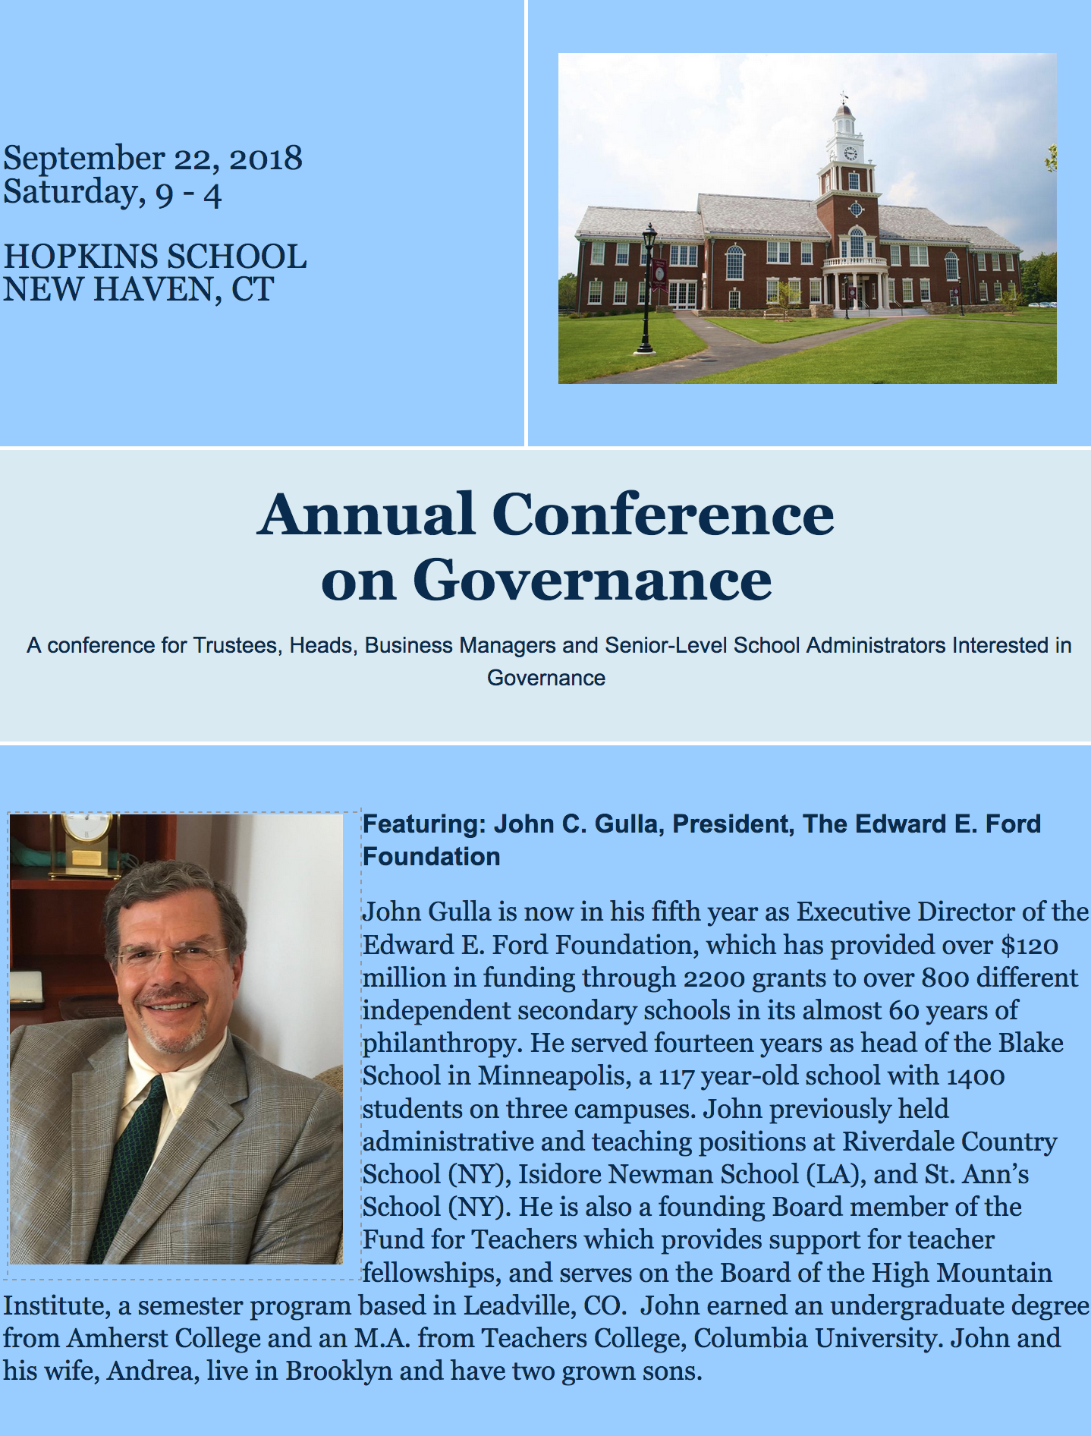
SESSION SCHEDULE

8:30 | CONTINENTAL BREAKFAST AND REGISTRATION
9:00 | Welcome  Doug Lyons, Executive Director, Connecticut Association of Independent Schools
9:30 - 10:30  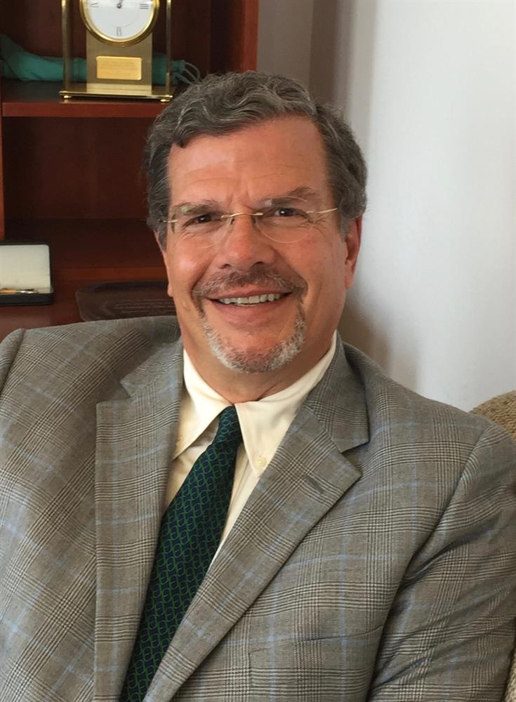 | MORNING KEYNOTE ADDRESS  Can You See What's Ahead by Traveling Around?  John C. Gulla, President, The Edward E. Ford Foundation  What challenges and opportunities might the next 5-10 years bring for independent schools? What nationwide patterns now exist, both in day and in boarding schools, as communities adapt to a rapidly changing landscape? What might heads and boards consider as they chart a course forward for their schools? I'll describe what I've seen and what I'm thinking after five years at the EE Ford Foundation based on the 350+ schools I've visited and with which I've been working. I'll discuss the types of initiatives we've been seeing at the Foundation, the ways schools are addressing the ever-present concerns about a "sustainable financial model" and some nascent thoughts about how the short-term and long-term perspectives sometimes collide for boards and heads.
10:45 - 12:15 | MORNING BREAKOUT SESSIONS (Choose One)
A.1 Conversation with John C. Gulla
In this follow-up to the morning keynote, John will facilitate a discussion about the challenges and opportunities raised during his presentation.

A.2 The Ideal Board-Head Relationship
Douglas Lyons, Executive Director, Connecticut Association of Independent Schools
The relationship between a board and its head of school is often identified as the factor most critical in determining the success of a school in meeting its goals and serving its students. An essential element in that relationship is mutual understanding of the roles and responsibilities of the head and board. This session will explore the factors that contribute to an ideal Board-Head relationship.
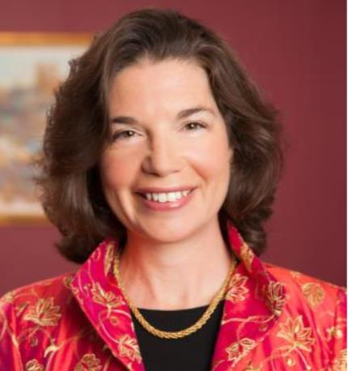 | A.3 Compensation and Contracts for the Head of School: Tips, Traps and Best Practices  Sarah Goldsmith Schwartz, Founder and President, Schwartz Hannum PC  This interactive session, facilitated by Sara Schwartz, who is a seasoned legal advisor relied upon by the leaders of more than 200 educational institutions for creative and strategic advice, will explore the Head of School contract process – both initial and renewal contracts. Sara will outline the key terms to include in Head of School contracts, benchmarking requirements and best practices, address rebuttable presumption obligations, and also review the current trends in benefits being provided to Heads. Will the Head be residing on campus? Sara will review best practices and legal requirements for faculty housing arrangements, including housing guidelines and an analysis of the tax consequences of conferring this benefit. Real world examples of legal disputes between schools and Heads will be discussed and used as learning opportunities. Attendees will be provided with checklists of issues to address in Head of School contracts, as well as in contracts with search firms.
A.4 The Trustee's Role in Fundraising: Solicitation Savvy, Fearless Fundraising
Starr Snead, Advancement Connections
Fundraising is a core responsibility of every member of the Board. In this session, we review the essentials of school philanthropy and uncover strategies designed to involve all board members in the fundraising process. We’ll explore a three-tiered approach that can help even the most reluctant volunteers overcome “solicitation paralysis.” Whether your school is looking to move its annual fund to new heights or is actively engaged in a capital or major gifts campaign, the ability to make THE ASK – appropriately and persuasively – is key.

A.5 Creativity in the Board Room: Developing a Creative Mindset
Dr. Richard Branson, Head, Indian Creek School; Executive Director-elect, CAIS
As Trustees we hear about creativity in the classroom, but how about creativity in the Board room? Solutions to challenges to independent schools might not only be found in strategic plans or finding operational efficiencies but by tapping into our creativity through client empathy, learning from failure, and finding inspiration. This session invites a conversation about developing a creative mindset and how to practice it as a team of Trustees so we can support our schools as they strive for innovation.
A.6 Endowments 101: Introduction to Endowments
Robert R. Sedivy, Ph.D., Retired School CFO
What is an endowment? What are the types of endowments? How are they created? What is a quasi-endowment? How much of an endowment gift can be used to support a school's program? Why should my school have endowments when there are so many current needs to be met? This session will provide​answers to these and other​basic questions about endowments, and review a school’s obligations under recent laws and accounting standards. This session is especially recommended for trustees new to the Finance Committee of their Board, and for trustees at​schools just starting to establish endowments.
12:30 - 2:00 |  | LUNCH KEYNOTE ADDRESS  What Every Head and Trustee Needs to Know About Enrollment Management  Heather Hoerle, Executive Director and CEO, The Enrollment Management Association  In the 20th century, the independent school admission office primarily served as an open door to your school’s campus, life, and culture for new families. Yet the work of enrollment management has changed in the 21st century, driven by an unstable economy, new market conditions and demographics, and the growth in K-12 educational competition. Though independent school enrollment figures have remained static since 2001, other forms of K-12 education have experienced exponential growth; indeed, charter and home schooling have grown substantially in the last decade, signaling new challenges for the independent school community in recruiting and retaining talented students.
2:15 - 3:45 |  | AFTERNOON BREAKOUT SESSIONS (Choose One)
B.1 Conversation with Heather Hoerle
Heather Hoerle, Executive Director and CEO, The Enrollment Management Association
In this follow-up to the lunch keynote, Heather will facilitate a Q&A on enrollment trends and challenges.
B.2 Is an Independent School Worth the Cost?
Douglas Lyons, Executive Director, Connecticut Association of Independent Schools
Advancements in neuroscience have given researchers a better understanding of how children learn. Two components of this research are particularly important for those who design environments for pre-collegiate learners: the role of emotion in learning and the impact of the total school environment in developing a life-long learner. Independent schools demonstrate a variety of organizing principles. They share a mission-driven, student-centered, culture-rich, non-bureaucratic model. This model has distinct and long-lasting advantages for students over the increasingly compliance-driven model that characterizes public education in the No Child Left Behind / Common Core era.
Is an independent school education worth the cost? This lecture will offer well-researched data and provocative information that will support the independent school Value Proposition.
​
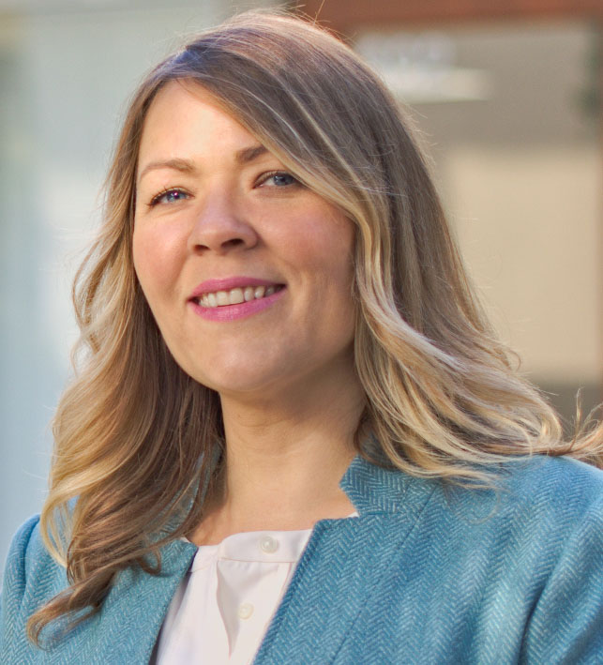 |  | B.3 Independent Schools in the Digital Age: What Every Trustee Needs to Know About Technology  Lisa Lamont, Director of Innovation and Technology, Hopkins School  With so many trends in education today, from online classes to the new technological gizmo, it can be difficult to assess what investments are the right ones for your school. Trustees need an understanding of technology in order to ensure that their schools can operate more efficiently, provide quality teaching and learning experiences to students, and through social media and online presence attract prospective families to their institutions. Most importantly, they must be able to ensure that the technological choices made help achieve the institution’s vision. This session will explore best practices for school leadership, examine trends in hiring and programming, and discuss implications of technology across the school. You will leave this session equipped with resources to engage with your fellow school leaders in a meaningful conversation about technology and a clearer understanding of how technology can support your school's mission.
B.4 Top Legal Risks for Trustees in 2018
Sarah Goldsmith Schwartz, Founder and President, Schwartz Hannum PC
This lively and interactive session, facilitated by Sara Schwartz, who is a seasoned legal advisor relied upon by the leaders of more than 200 educational institutions for creative and strategic advice, will provide an overview of this year’s top legal issues facing independent schools and trustees, including real life solutions for preventing and resolving these challenges. For example, Sara will discuss ways to prevent and respond to environmental hazards on campus, donor lawsuits, Head of School misconduct, and claims of inappropriate conduct by school employees and students. Sara will review governance best practices, including topics such as bylaws, conflicts of interest, whistleblower policies, and trustee agreements.
B.5 Capital Campaigns and Major Gifts: Trustees and Transformational Philanthropy
Starr Snead, Advancement Connections
What does it take to reel in capital and/or major gifts? Join this session to learn how to cultivate and steward donors for maximum return on investment. Drawing on anecdotal information and trend data, we’ll examine what motivates donors to give significant gifts to our schools and how trustees can play a part in developing strategies that tap into those transformational gifts. We’ll look at “major gift mechanics” including conducting a campaign readiness assessment; the difference(s) between annual, capital and major gift programs; and the role of trustees to move this important work forward.
B.6 Beyond Budget and Audit: Four Essential Financial Reports for Your Board
Robert R. Sedivy, Ph.D., Retired School CFO​
Once a year you approve the budget. Once a year you receive the school’s audited financial statements. What happens in between? This session discusses four essential financial reports which can help trustees meet their fiduciary responsibilities: budget-to-actual reports which provide context, not just a snapshot of the budget; long term trend reports, tracking essential facts about the school’s finances; forecasts of the money needed to meet the school’s plant renewal needs; and supplemental data reports which go beyond the minimal requirement and reporting constraints of the annual audit. This session is especially recommended for trustees new to the Finance Committees of their boards, and those who anticipate taking on leadership roles in their boards.

Registration fees BEFORE September 12th:
$162 for each school's initial registrant
$108 each for registrants 2-6 from the school
$90 each for registrants 7 and beyond from the school

Registration fees AFTER September 12th:
$180 for each school's initial registrant
$120 each for registrants 2-6 from the school
$100 each for registrants 7 and beyond from the school

Register at: www.caisct.org/governance18

